**Exercise 1: Control Structures**

**Scenario-1 Solution:**

BEGIN

FOR cust IN (

SELECT l.LoanID, l.InterestRate

FROM Customers c

JOIN Loans l ON c.CustomerID = l.CustomerID

WHERE c.Age > 60

) LOOP

UPDATE Loans

SET InterestRate = cust.InterestRate - 1

WHERE LoanID = cust.LoanID;

END LOOP;

COMMIT;

END;

Output 🡪

SELECT l.LoanID, c.CustomerName, c.Age, l.InterestRate

FROM Loans l

JOIN Customers c ON l.CustomerID = c.CustomerID;

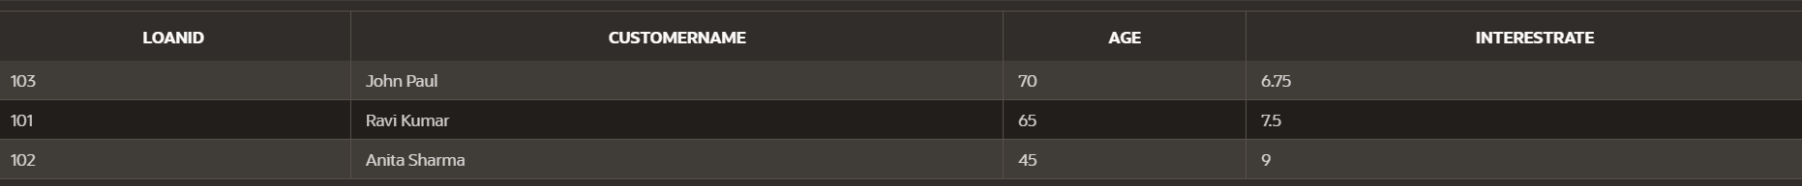

**Scenario-2 Solution:**

BEGIN

FOR cust IN (

SELECT CustomerID

FROM Customers

WHERE Balance > 10000

) LOOP

UPDATE Customers

SET IsVIP = 'TRUE'

WHERE CustomerID = cust.CustomerID;

END LOOP;

COMMIT;

END;

Output 🡪

SELECT CustomerID, CustomerName, Balance, IsVIP

FROM Customers;

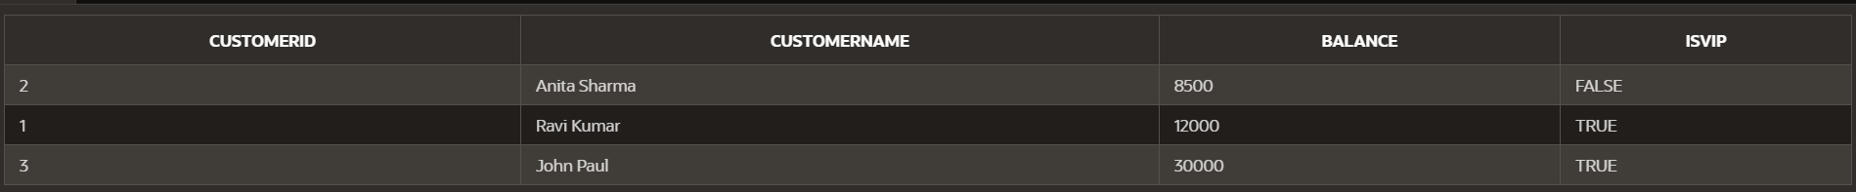

**Scenario-3 Solution:**

BEGIN

FOR loan IN (

SELECT c.CustomerName, l.LoanID, l.DueDate

FROM Loans l

JOIN Customers c ON l.CustomerID = c.CustomerID

WHERE l.DueDate BETWEEN SYSDATE AND SYSDATE + 30

) LOOP

DBMS_OUTPUT.PUT_LINE(

' Reminder: Dear ' || loan.CustomerName ||

', your Loan #' || loan.LoanID ||

' is due on ' || TO_CHAR(loan.DueDate, 'DD-MON-YYYY')

);

END LOOP;

END;

Output 🡪

